

|  |  |  |  |  |  |  |  |  |
| --- | --- | --- | --- | --- | --- | --- | --- | --- |
|  | | | | | | | | |
|  | | Project Report | | | | |  | |
|  |  | | | | | | |  |
|  | | | |  |  | | | |
|  | | | | SecureNetIntrusion Detection System |  | | | |
|  | | | | **May 14, 2024****—****Computer Networks****—****Waseem Rauf** **Group Members:**  Talha Bilal (K21-3349)  Ahmed Ali (K21-3212)  Taha Hassan (K21-4680) |  | | | |
|  | | |  | | |  | | |

**Contents**

**Project Report 1**

**1. INTRODUCTION 3**

**1.1. Background 3**

**1.2. Purpose of Report: 3**

**1.3. Intended Audience: 3**

**2. METHODOLOGY 4**

**3. RESULT 5**

**3.1. Scenarios 5**

**3.1.1. Send Packet (between Two Floors) Scenario 5**

**3.1.2. Command Line Interface (CLI) Scenario 6**

**3.1.3. Website Scenario 6**

**3.1.4. IP-Phone Scenario 7**

**3.1.5. CCTV Scenario 7**

**3.2. Topology 8**

**3.2.1. Configurational Steps 8**

**3.2.2. Full Network Topology 12**

**4. CONCLUSION 13**

**5. REFERENCES 13**

# INTRODUCTION

In today's interconnected landscape, computer networks serve as the backbone linking various devices, whether wired or wirelessly, ranging from computers and phones to printers and mobile devices. The internet, a vast network, governs data flow with speed limits and quotas, facilitating global resource sharing among different networks. While physically connecting computers remains an option, it often entails space and cable redundancies. Switches play a pivotal role in optimizing communication efficiency between multiple devices within networks. Understanding the complexities of networks necessitates practical experience, particularly in light of technological advancements. Simultaneously, network security stands as a cornerstone for safeguarding sensitive data and ensuring the integrity of systems. An Intrusion Detection System (IDS) plays a critical role in identifying and responding to unauthorized access attempts, malicious activities, and other security threats. With the increasing complexity of cyber threats, having an effective IDS is essential for safeguarding network assets and maintaining operational continuity.

## Background

Virtual laboratories offer interactive, real-time simulations for practical experience in education, bridging gaps between theory and practice. They enable demonstrations of applications that are impossible or impractical to conduct in traditional laboratory settings. Computer simulations aid in modeling and analyzing various systems, from physics and chemistry to economics and social sciences. In network areas, simulation technology facilitates tasks like traffic simulation and overall structure modeling. Computer-aided simulation tools are crucial for network simulations, emphasizing performance and validity of protocols and algorithms. The development of network simulation tools aligns with the rapid advancements in network technologies, emphasizing support for commonly used algorithms and protocols.

## Purpose of Report:

1. The significance of network security in the modern interconnected landscape.
2. To underscore the critical role of Intrusion Detection Systems (IDS) in safeguarding sensitive data and ensuring operational continuity.
3. To highlight the escalating complexity of cyber threats and the imperative need for effective security measures.
4. To advocate for proactive strategies and investment in IDS technologies to mitigate risks and uphold system integrity.

## Intended Audience:

1. Network administrators and IT security professionals responsible for implementing and managing network security measures.
2. Executives and decision-makers in organizations seek to understand the importance of network security in maintaining business continuity.
3. Students and professionals in cybersecurity and network engineering fields looking to enhance their understanding of IDS technology and its applications.
4. Government agencies, regulatory bodies, and policymakers concerned with cybersecurity governance and policy formulation.

# METHODOLOGY

* 1. **Formation of Network Topology**

The network is built using Cisco Packet Tracer Program, featuring a topology designed for a 5-storey hotel. It includes 7 computers, 5 laptops, 3 tablets, 5 IP phones, 14 switches, 3 routers, 5 access points, and various servers and devices. The network design encompasses security measures like a security wall and DHCP server. Additionally, devices such as cameras, tablets, smartphones, and an IoT server are integrated for diverse functionalities within the network.

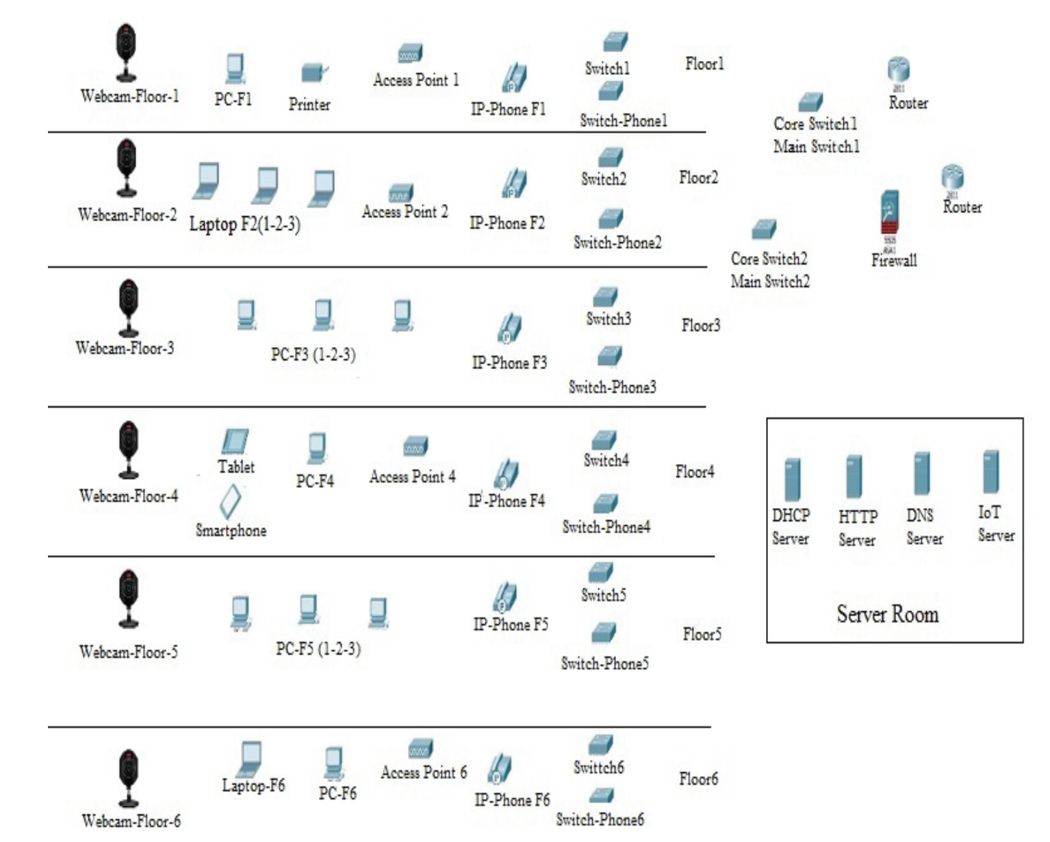

# RESULT

The results have been produced by the Packet Tracer for the different scenarios.

## Scenarios

To prove the Packet Tracer is suitable and applicable to design and implement network. In addition, the Packet Tracer is very important to use in the learning computer networks, five different scenarios have been used.

### **Send Packet (between Two Floors) Scenario**

In this scenario we will send a message from computer device on the first floor to another computer device on the fifth floor and we will note how the message moves step by step in order to reach the destination as shown below:

* First step, the packet was redirected to Switch.
* Second step, Switch1 redirected the package to Core Switch.
* Third step, Core Switch2, redirected the package to Switch.
* Forth step, Switch6, redirected the package to Access Point.
* Fifth step finally, the package was successfully sent from the Access Point to the target user (Laptop)

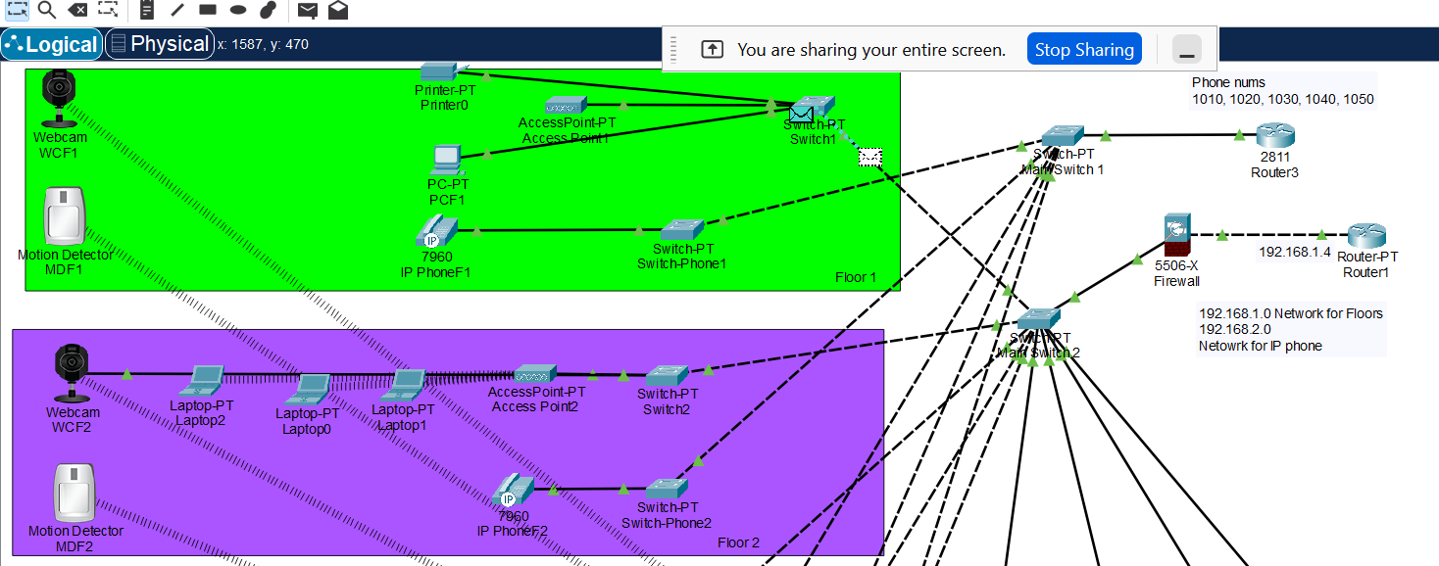

### **Command Line Interface (CLI) Scenario**

In this scenario we will use the command line interface (CLI) between any two devices in the network to prove all devices connected between each other as shown below:

First step, we enter the computer device interface on any floor and login to Command Prompt in order to send ping between any two devices.

Second step, then we specify the target device IP address by giving the target ping command.

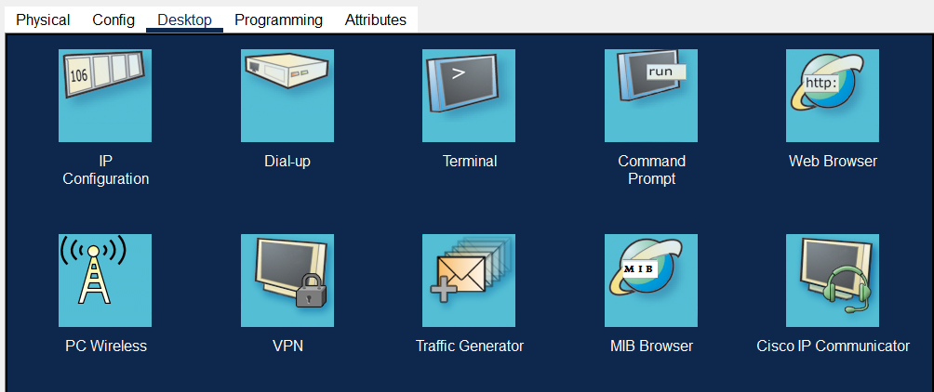

### **Website Scenario**

In this scenario we will implement the Website for the purpose of accessing the Website pages as shown below:

* First step, in order to login to the Website, it is entered to the interface of any network device connected to the network and the Web Browser button is clicked.
* Second step: Then http://hello.com is written on the address line. Once this is done, the DNS server will be asked for the IP address of hello.com. Since DNS server knows the IP address of the hello.com domain name, it directs the user to the IP address where the HTTP server is located so that the user will be faced with the web interface. Then, a phrase will appear on the page (Welcome to Our CN Project).

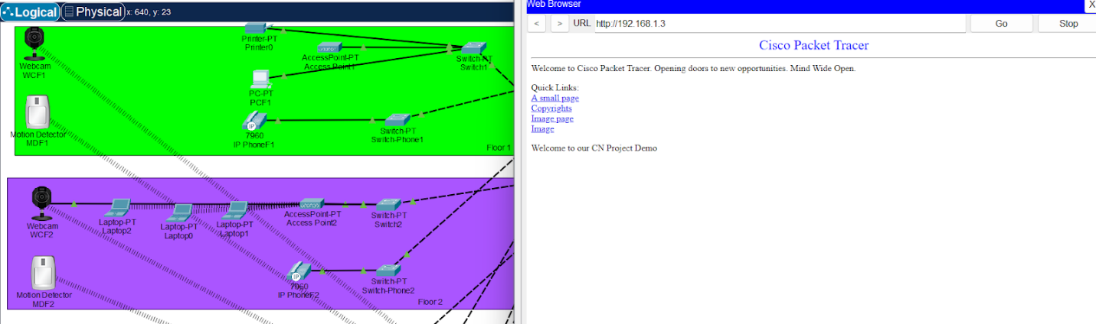

### **IP-Phone Scenario**

In this scenario we will use IP-Phone device to make a telephone call between two phone devices located on second floor and fifth floor of the hotel to prove that the network is also used by telephone devices well.

* First step, the interface of the phone on the second floor is entered.
* Second step, the 5th-floor telephone number is entered the phone (1040).
* Third step, the phone is opened by clicking on the phone.
* Forth step, the interface of the phone on the 5th floor is opened and the call is answered by clicking on the phone.

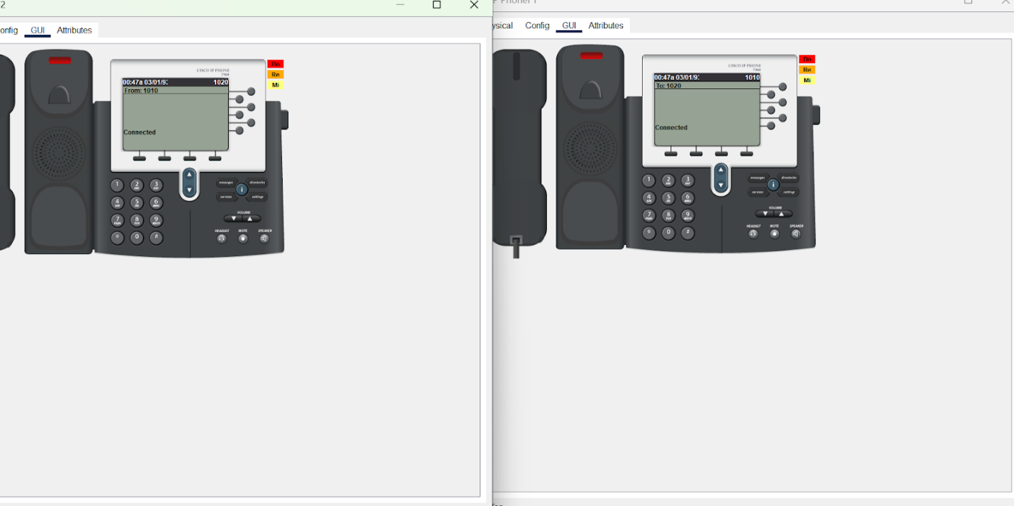

### **CCTV Scenario**

In this scenario, to prove that the security of the building is very important, surveillance cameras were used to monitor all the building floors and connect these cameras to the network. Moreover, Thanks to CCTV, the view from the security cameras is realized. The floors can be monitored at any time thanks to the cameras which are provided with each crawler and thus security is ensured. To monitor security cameras, enter the interface of a device connected to the network and perform the following steps:

* First step, for the first time it is entered to the interface of the networked device and the web browser button is clicked.
* Second step: IoT server, IP address is written on address line.
* Third step, the floor to be watched is selected.
* The fourth and last step, after selecting the floor to be seen on the screen, people who enter the floor appear to us.

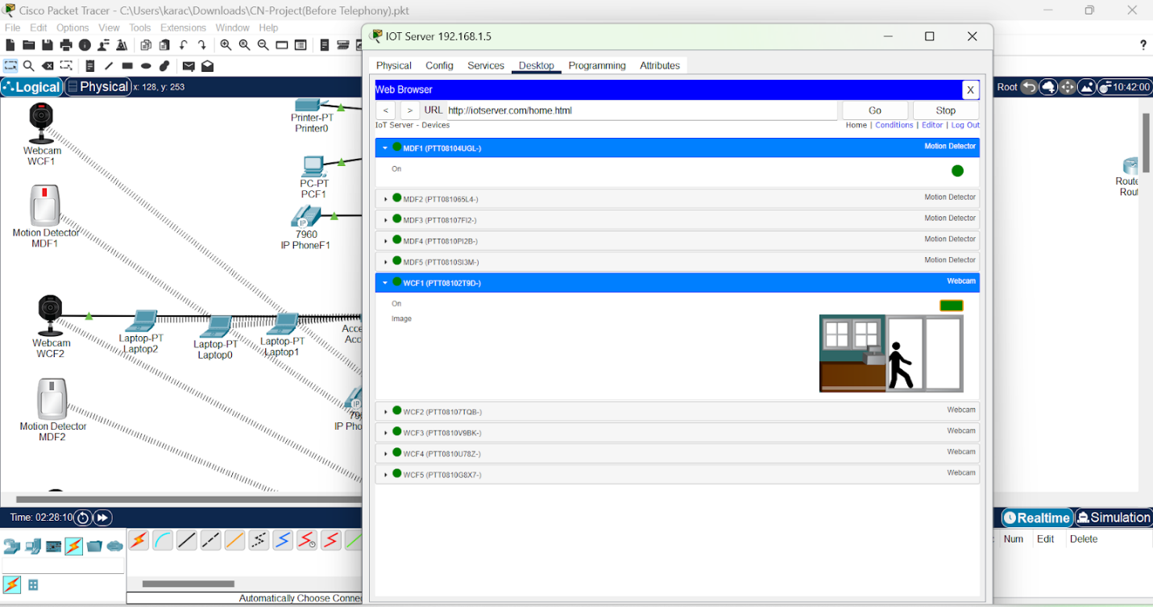

## Topology

### **Configurational Steps**

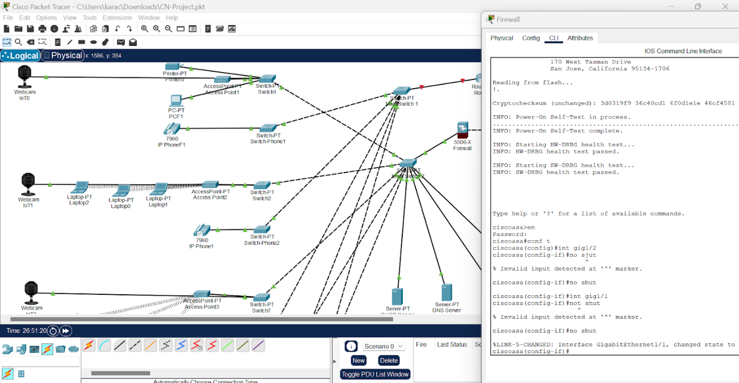

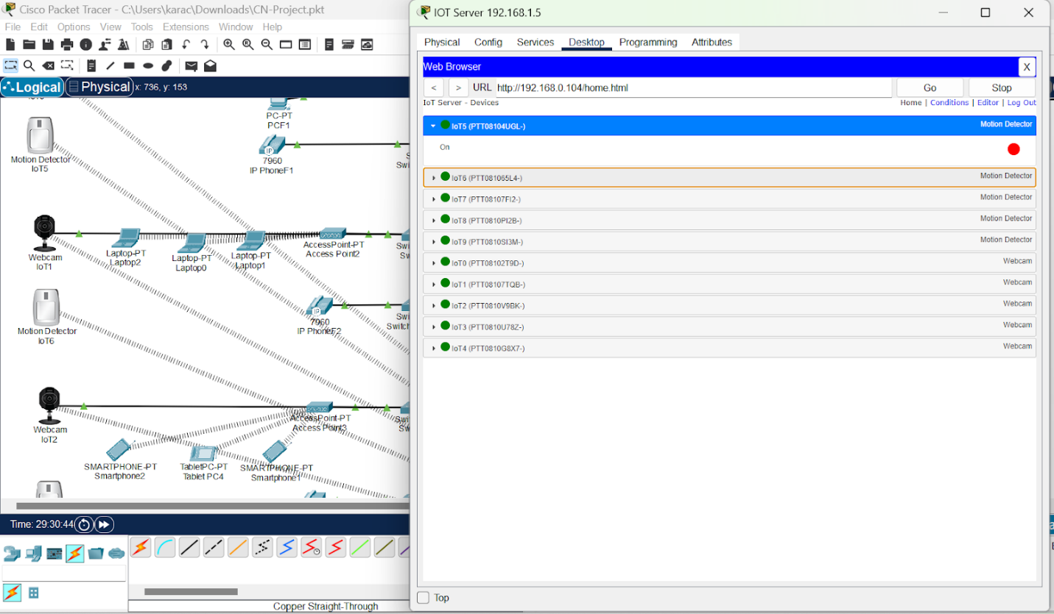

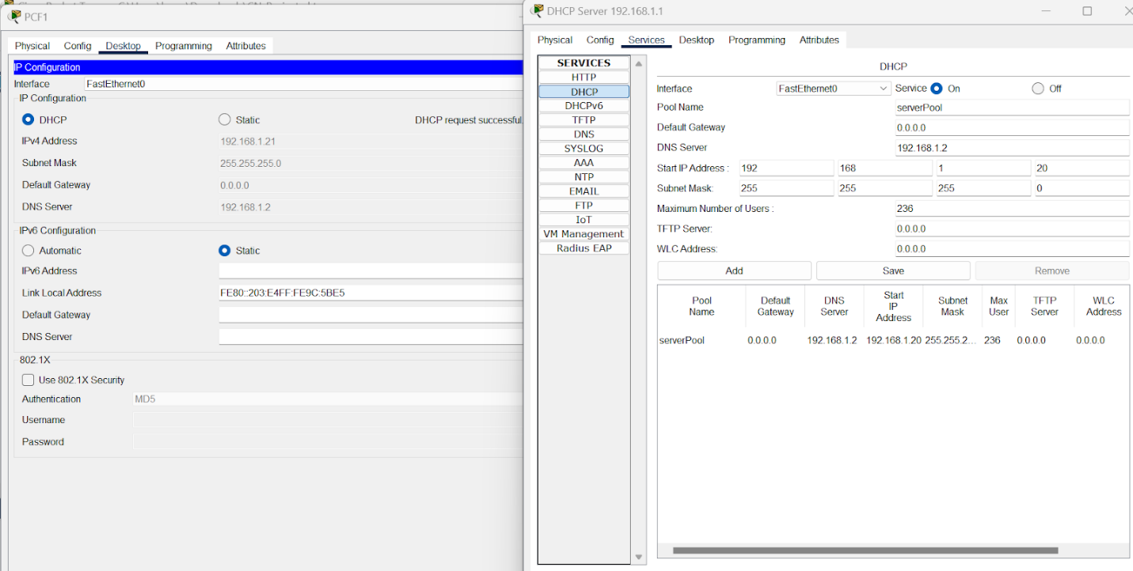

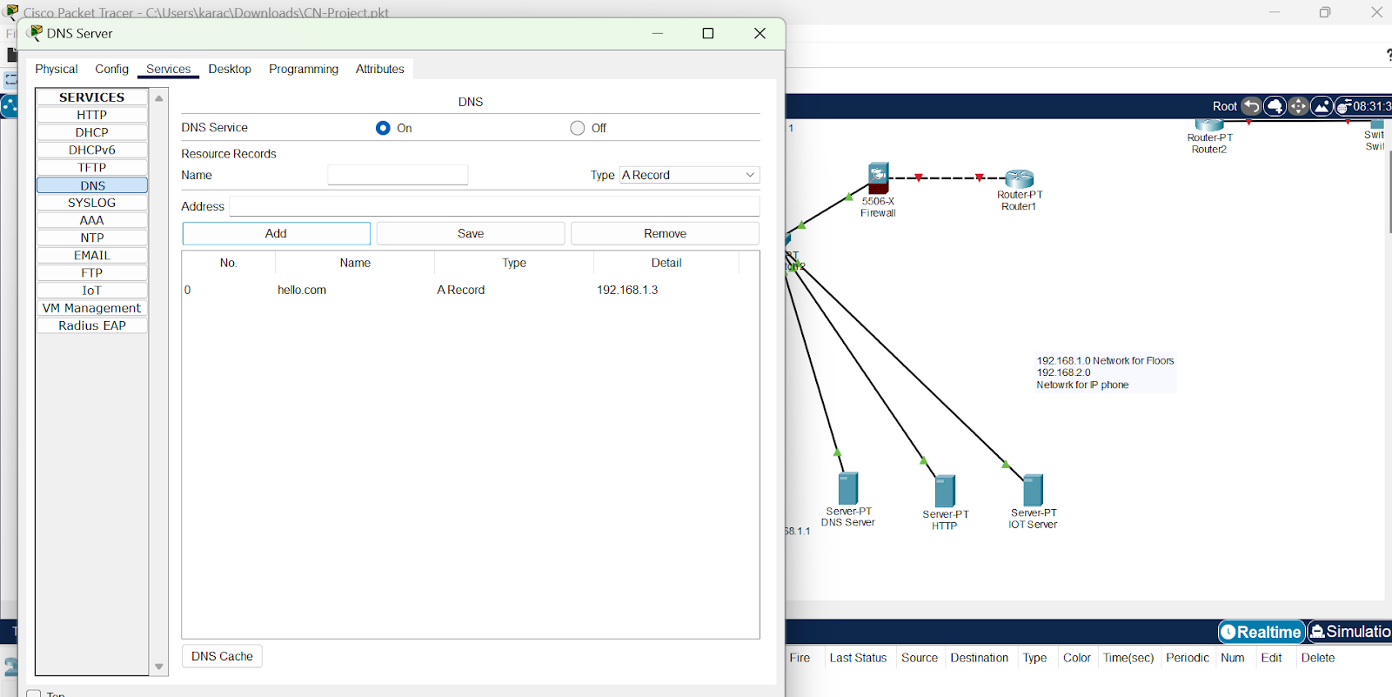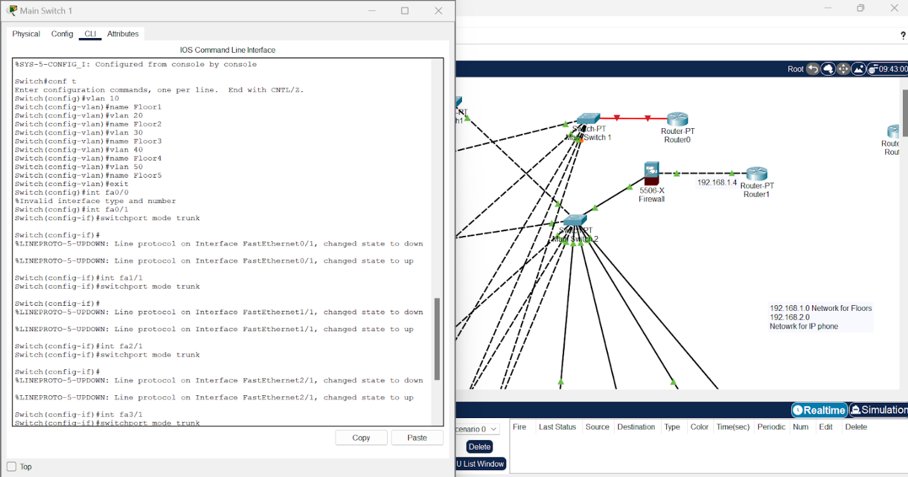

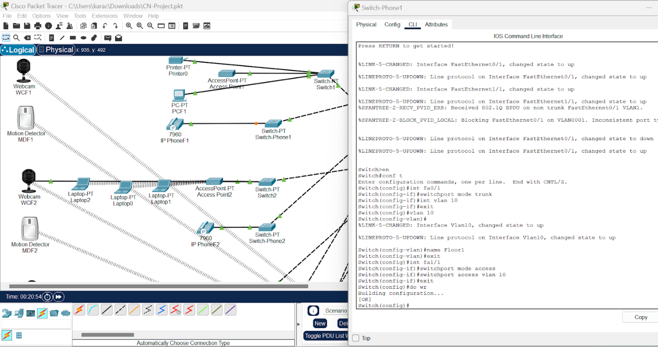

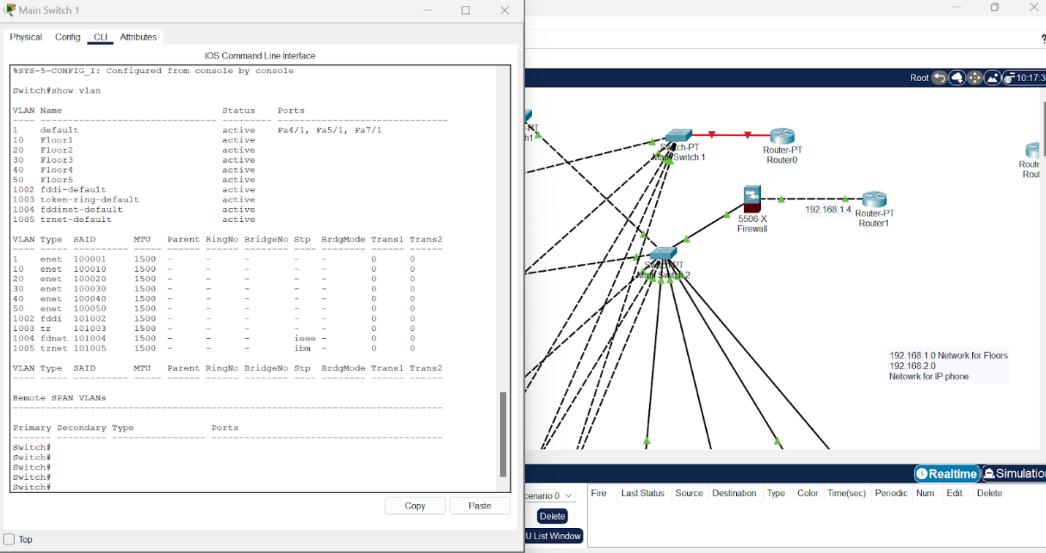

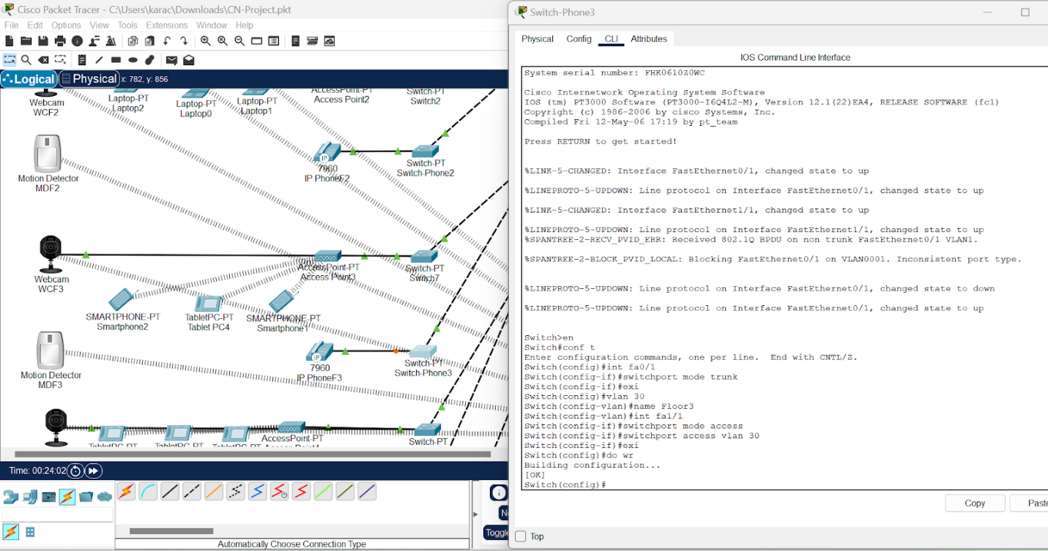

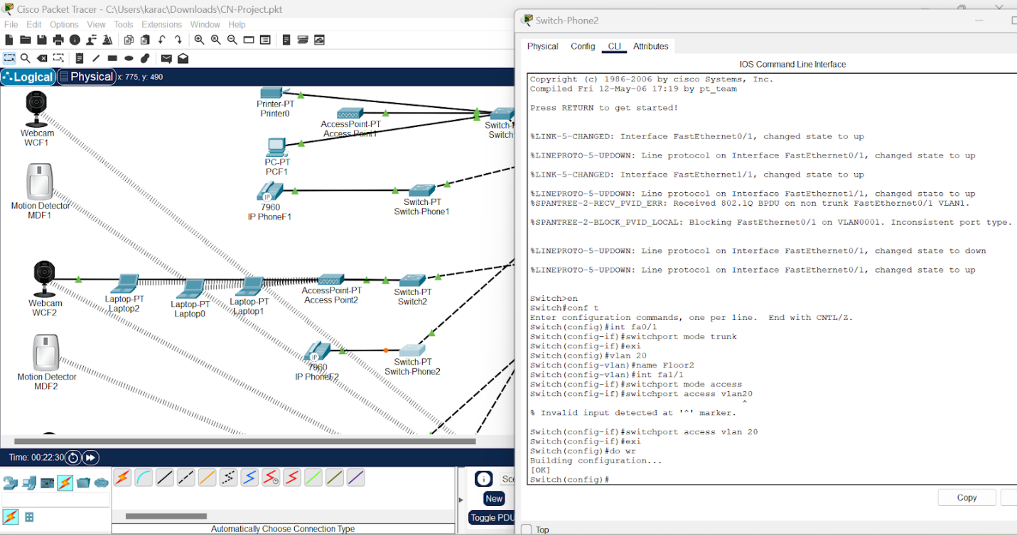

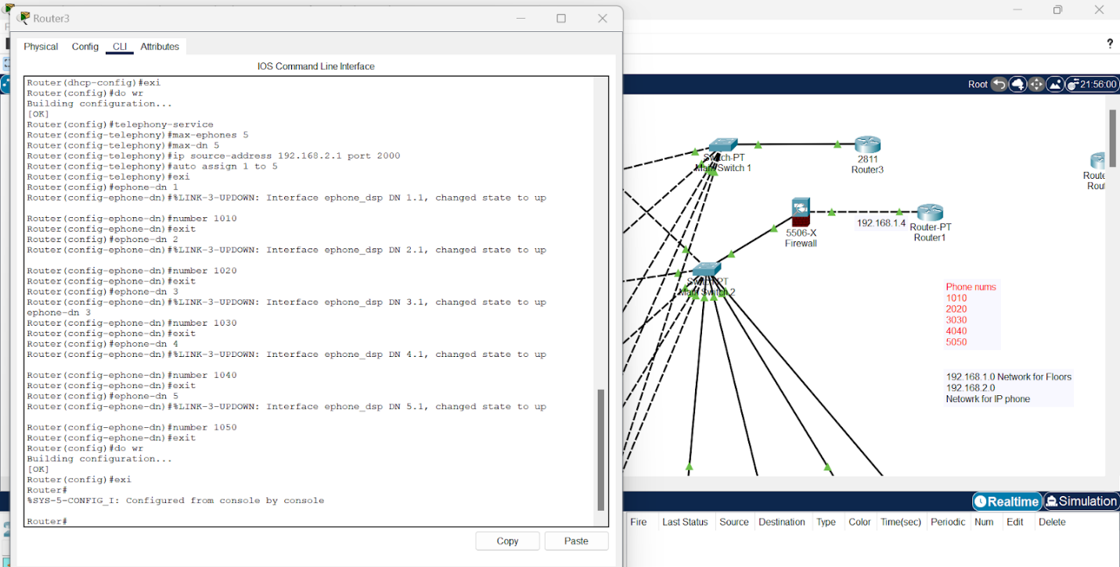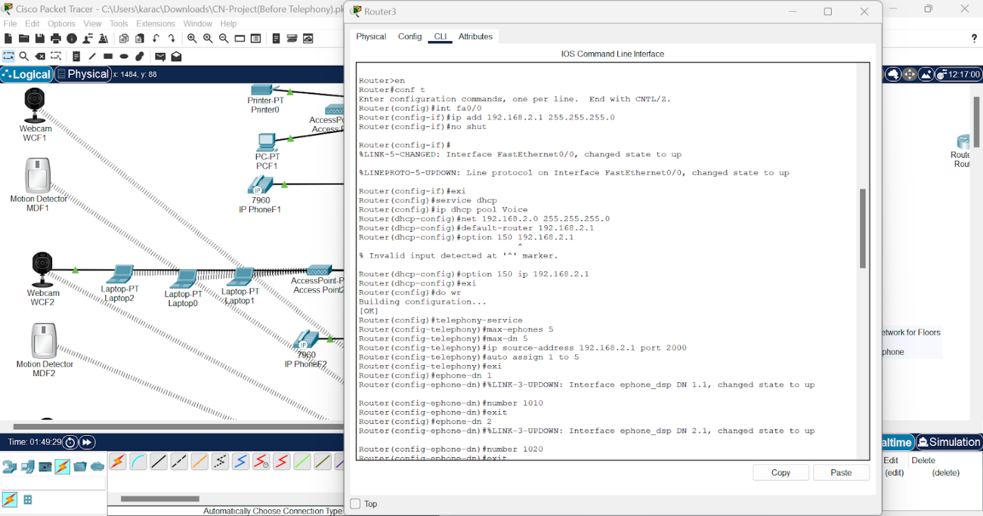



### **Full Network Topology**

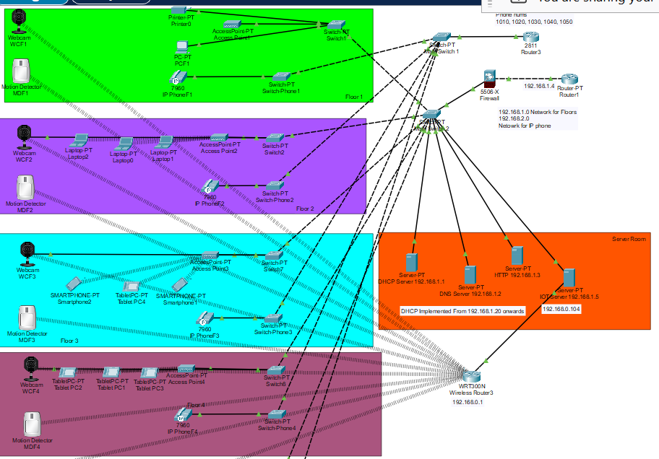

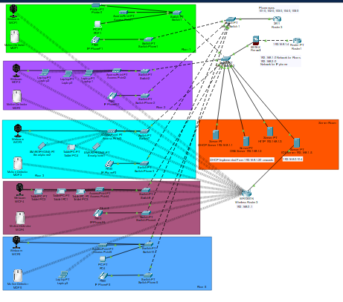

# CONCLUSION

In conclusion, the implementation of an Intrusion Detection System (IDS) on Cisco Packet Tracer represents a proactive step towards enhancing network security. By leveraging Packet Tracer's capabilities, we aim to fortify network infrastructures by detecting and responding to security threats effectively. Through simulations of real-world network environments, we can evaluate the IDS's performance in identifying and mitigating various intrusions. This project empowers network administrators with a powerful tool to safeguard their networks against evolving cyber threats. Moving forward, the integration of IDS into network designs offers a crucial layer of defense, ensuring operational continuity and protecting sensitive data. As technology evolves, leveraging tools like Packet Tracer becomes essential in staying ahead of cyber threats and maintaining a robust security posture in interconnected environments.

# REFERENCES

* Taşdelen, K. (2004). Interactive based, Interactive, Virtual Microcontroller , Laboratory Design for Engineering Education, Graduate Thesis, Süleyman Demirel University, Institute of Science, Isparta.
* Jakab František, Janitor Jozef, Visual Learning: Case Study of Cisco Networking Academy’s PACKET TRACER 5.0 Application, Proc. Of 6th International Conference on Emerging eLearning Technologies and Applications
* Odom, W. (2004). Computer Networking first-step. Cisco Pres
* <https://www.youtube.com/watch?v=_sr9yTw20FU>